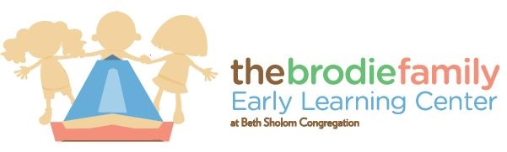

PERMISSION FOR USE OF A PACIFIER AT EARLY LEARNING AT BETH SHOLOM

The caregivers have my permission to give my child,
Please print child’s name____________________________________________________
Her/his pacifier.
Any instructions or preferences that the caregivers need to know about the use of the pacifier: ________________________________________________________
__________________________________________________________________
I understand that I must send in 2 pacifiers, labelled with my child’s name.
Parent’s name________________________________________________
Parent’s signature_____________________________________________

